Vacation Care December 2021

“Due to current Government Health Guidelines & recommendations BHPS OSHC & Vacation Care may be required to make changes to the program with little notice. Updates will be passed on as they become available, BHPS OSHC and Vacation Care will follow DECD policy & Government Health regulations when putting in place any changes. All excursions/incursions are planned using strict Covid-19 guidelines”
Mon 13/12/21 | Tues 14/12/21 | Wed 15/12/21 | Thurs 16/12/20 | Fri 17/12/21
Santa’s Workshop  Outcome 4: Children are confident and involved learners  Take a trip to the North Pole.  Bake Christmas treats in Mrs. Clause’s Kitchen. Get creative with the Elves and make Christmas ornaments and suncatchers.  Relax with Rudolph and friends by listening to music and watching a Christmas movie. | Movie Day  Outcome 5: Children are effective communicators  Q. Did you hear about the Minecraft movie?  A. It’s a Blockbuster  Join us on an excursion to Wallis Cinemas at Mitcham in our own private cinema.  Excursion cost $10.  No spending money | Holly Jolly Christmas  Outcome 2: Children are connected with and contribute to their world  Get into the festive spirt with a day filled with Christmas themed fun.  Make your own bon-bon, get creative with Christmas sand art. Watch Christmas movies and play Christmas themed games. | OSHCHELLA  Outcome 1: Children have a strong sense of identity  Join us for OSHCHELLA a fun filled end of year break up party.  Jump into fun on the Jumping Castle have a yummy treat from the Fairy Floss Machine.  Dance and listen to music, play giant games.  Look the part with colourful hair braids, temporary tattoos and sparkle with face glitter.  Incursion Cost $10 | Sloth Day  Outcome 3: Children have a strong sense of wellbeing  Embrace your inner sloth on Sloth Day.  Relax with movies, board games, Nintendo Switch and drawing.  You can also do some yoga and lay back on the cushions.  Just RELAX!!
Transport: N/A  Depart: N/A  Return: N/A  Bring: Recess, lunch, water bottle, hat, sunscreen | Transport: Private Bus  Depart: 10.45am  Return: 3.00pm  Bring: Recess, lunch, water bottle, hat, sunscreen | Transport: N/A  Depart: N/A  Return: N/A  Bring: Recess, lunch, water bottle, hat, sunscreen | Transport: N/A  Depart: N/A  Return: N/A  Bring: Recess, lunch, water bottle, hat, sunscreen | Transport: N/A  Depart: N/A  Return: N/A  Bring: Recess, lunch, water bottle, hat, sunscreen

Year “6’s” & “7s” can still get CCS % until end of December. They can attend Vacation Care after this at no CCS-Full Price.
We would like to thank all our families for their support over the year and from all the staff at OSHC and Vacation Care we wish you a “Very Merry Christmas” and a “Happy New Year”.

Vacation Care will be closed for three weeks 20th December 2021 – 7th January 2022. Returning Monday 10th January.
Vacation Care January 2022

Mon 10/01/22 | Tues 11/01/22 | Wed 12/01/22 | Thurs 13/01/22 | Fri 14/01/22
Electronics Day  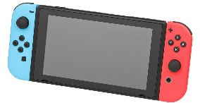  Suggested by Josh  Outcome 5: Children are effective communicators  Relax and unwind at Electronics Day.  Play on the Nintendo Switch, use the OSHC tablets and computers and watch a movie.  You may bring in your own electronics and devices.  OSHC will not be responsible for any lost or damaged items. | Water Play Day  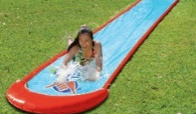  Suggested by Ava & Lily  Outcome 1: Children have a strong sense of identity  Join us for Water Play Day. Play on the slip ‘n’ slide & run through the sprinkler.  Play with the water shooters & sponges.  Remember your bathers, rashie, sunscreen, plastic bag, thongs & towel. | 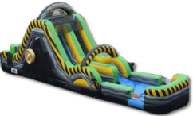  Giant Water Slide  Outcome 3: Children have a strong sense of wellbeing  Let’s have fun on the Rock Climb Water Slide.  We will have all day to enjoy the water slide.  Incursion cost $8.  Remember your sunscreen, bathers, rashie, thongs, towel and plastic bag. | 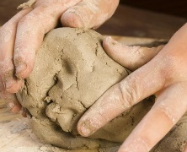  Craft-topia  Outcome 4: Children are confident and involved learners  Get ready for a fun filled day of craft. Make your own clay figure to take home.  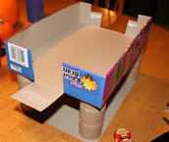  Create your own jewellery, painting or box construction masterpiece. | Movie Day  Outcome 3: Children have a strong sense of wellbeing  Q. Have you heard of the movie about a broom?  A. It’s sweeping the Nation  Join us on an excursion to Wallis Cinemas at Mitcham in our own private cinema.  Excursion cost $10.  No spending money
Transport: N/A  Depart: N/A  Return: N/A  Bring: Recess, lunch, water bottle, hat, sunscreen | Transport: N/A  Depart: N/A  Return: N/A  Bring: Recess, lunch, water bottle, hat, sunscreen, bathers, towel, plastic bag | Transport: N/A  Depart: N/A  Return: N/A  Bring: Recess, lunch, water bottle, hat, sunscreen, bathers, towel, plastic bag | Transport: N/A  Depart: N/A  Return: N/A  Bring: Recess, lunch, water bottle, hat, sunscreen | Transport: Private Bus  Depart: 10.45am  Return: 3.00pm  Bring: Recess, lunch, water bottle, hat, sunscreen
Mon 17/01/22 | Tues 18/01/22 | Wed 19/01/22 | Thurs 20/01/22 | Fri 21/01/22
Marion Outdoor Pool  Suggested by Nika  Outcome 2: Children are connected with and contribute to their world  We’re going to Marion Outdoor pool to swim, enjoy the slides and water play park.  Remember your sunscreen, bathers, a plastic bag, rashie, thongs and towel.  Must be over 5yrs  Excursion cost $10 | Games, Games, Games!  Suggested by Danny  Outcome 5: Children are effective communicators  Get your game on!  At our game themed day, play giant games, group games, gameshow games and boardgames.  You may bring games from home to share. | OSHC Bake Off  Suggested by Ines  Outcome 2: Children are connected with and contribute to their world  Ready, steady, bake!  Get into the kitchen and bake up a storm.  Everyone will be split into teams to bake, cook and present their teams dish to the judges.  You will get to try the other teams’ dishes and go home with a recipe book. | Giant Water Slide  Suggested by Lizzy  Outcome 1: Children have a strong sense of identity  Let’s have fun on the Rock Climb Water Slide.  We will have all day to enjoy the water slide.  Incursion cost $8.  Remember your sunscreen, bathers, a plastic bag, rashie, thongs and towel. | Mad Science  Outcome 4: Children are confident and involved learners  Investigate, hypothesise and experiment.  Investigate how things work at the tinkering table. Make slime and hypothesise on what will happen in the mad science lab.  Experiment with aerodynamics; make your own rocket or paper plane.
Transport: Private Bus  Depart: 8.45 am  Return: 2.00pm  Bring: Recess, lunch, water bottle, hat, bathers, towel, plastic bag, sunscreen | Transport: N/A  Depart: N/A  Return: N/A  Bring: Recess, lunch, water bottle, hat, sunscreen | Transport: N/A  Depart: N/A  Return: N/A  Bring: Recess, lunch, water bottle, hat, sunscreen | Transport: N/A  Depart: N/A  Return: N/A  Bring: Recess, lunch, water bottle, hat, bathers, towel, plastic bag, sunscreen | Transport: N/A  Depart: N/A  Return: N/A  Bring: Recess, lunch, water bottle, hat, sunscreen
“Due to current Government Health Guidelines & recommendations BHPS OSHC & Vacation Care may be required to make changes to the program with little notice. Updates will be passed on as they become available, BHPS OSHC and Vacation Care will follow DECD policy & Government Health regulations when putting in place any changes. All excursions/incursions are planned using strict Covid-19 guidelines”
Vacation Care January 2022

Mon 24/01/22 | Tues 25/01/22 | Wed 26/01/22 | Thurs 27/01/22 | Fri 28/01/22
Messy Play Day  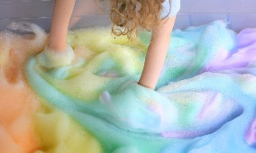  Suggested by Rhiannon  Outcome 4: Children are confident and involved learners  Let’s get messy!  Join us for messy fun with messy play day. There will be foam, bubbles, jelly bath, painting and more.  Remember to bring old clothes that can get dirty. | Swimming  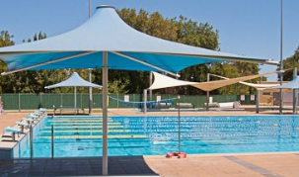  Suggested by Joe  Outcome 1: Children have a strong sense of identity  Cool off at the Unley Swimming Centre. Enjoy a day of swimming and pool fun.  Remember your bathers, rashie, sunscreen, plastic bag, thongs and towel.  Must be over 5yrs  Excursion cost $10 | PUBLIC HOLIDAY | 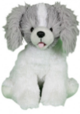  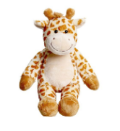  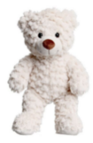  Teddy Bears’ Picnic  Outcome 3: Children have a strong sense of wellbeing  If you go into the woods today…  We will be making our very own teddy bears and friends from “Make My Bear” to take home.  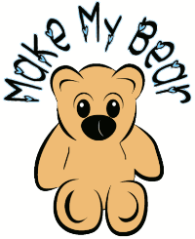  After we will have a Teddy Bears Picnic with our new cuddly friends.  Incursion Cost $10 | PJ Party  Outcome 5: Children are effective communicators  Come join us for our Pj Party! Play party games and join us for a special pizza lunch.  Play just dance, tell stories, relax and watch a movie.  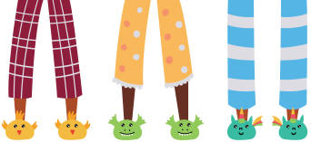  Wear your Pj’s. You may also bring a teddy and pillow.
Transport: N/A  Depart: N/A  Return: N/A  Bring: Recess, lunch, water bottle, hat, sunscreen, change of clothes | Transport: Private Bus  Depart: 10.15 am  Return: 2.30pm  Bring: Recess, lunch, water bottle, hat, sunscreen, bathers, towel, plastic bag, | Transport: N/A  Depart: N/A  Return: N/A  Bring: N/A | Transport: N/A  Depart: N/A  Return: N/A  Bring: Recess, lunch, water bottle, hat, sunscreen | Transport: N/A  Depart: N/A  Return: N/A  Bring: Recess, lunch, water bottle, hat, sunscreen
“Due to current Government Health Guidelines & recommendations BHPS OSHC & Vacation Care may be required to make changes to the program with little notice. Updates will be passed on as they become available, BHPS OSHC and Vacation Care will follow DECD policy & Government Health regulations when putting in place any changes. All excursions/incursions are planned using strict Covid-19 guidelines”
Hot weather/Sun Safety Reminder:
Children must wear a sun safe hat when outside, on excursions children must wear maroon school hat. Children need to wear sun safe clothing with their shoulders covered no singlet tops. Children should arrive to OSHC with sunscreen on and parents/caregivers to tick box on sign in sheet. Children are to wear appropriate footwear, thongs are not to be worn on excursions or when playing outside children who are wearing thongs should pack enclosed shoes in their bag.

